NATIONAL UNIVERSITY OF MODERN LANGUAGE ISLAMABAD
DOM lab


Submitted to:
Ms. Saadia Shabbir
Submitted by:
Zulqarnain Hassan
Roll No: …………………… SP21379
Subject: …………………… Web engineering
Department: ……………… BSSE-5-Afternoon
Date: ……………………… 10-01-2025

Task 01
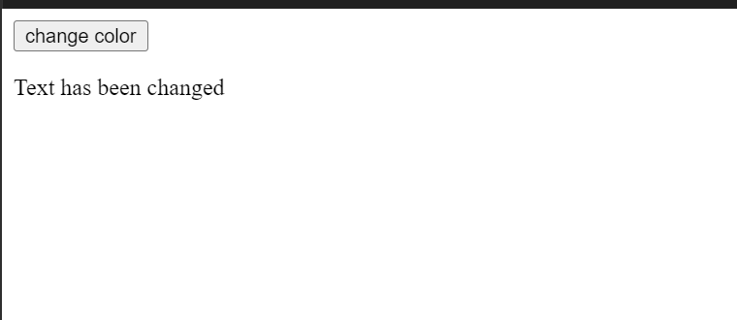

Task 02
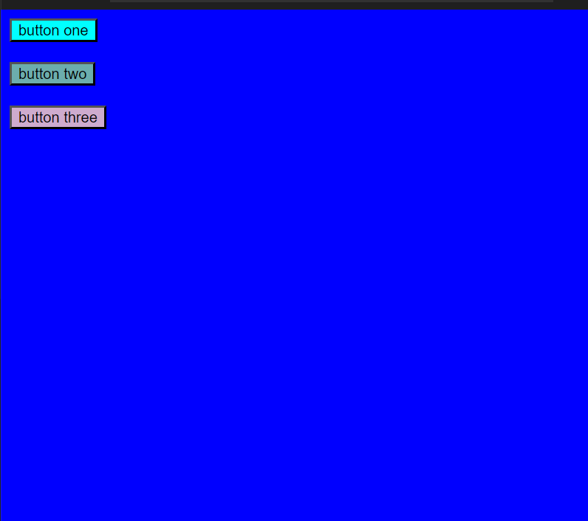

Task 03
